Robert Lumley
'Sit in: Art, Design and Politics in Italy in the 1960s'

My aim is not to provide a guide to chairs and sitting, but to use the chair and the idea of sitting as a device to 'think with'. I want to think in particular of the role of home and the domestic sphere in the work of Italian artists in the 1960s. The chair is conceived not in isolation but as subject to art practices in which the whole idea of home, way of life and the stable object were called in question.
I am offering notes of work-in-progress.

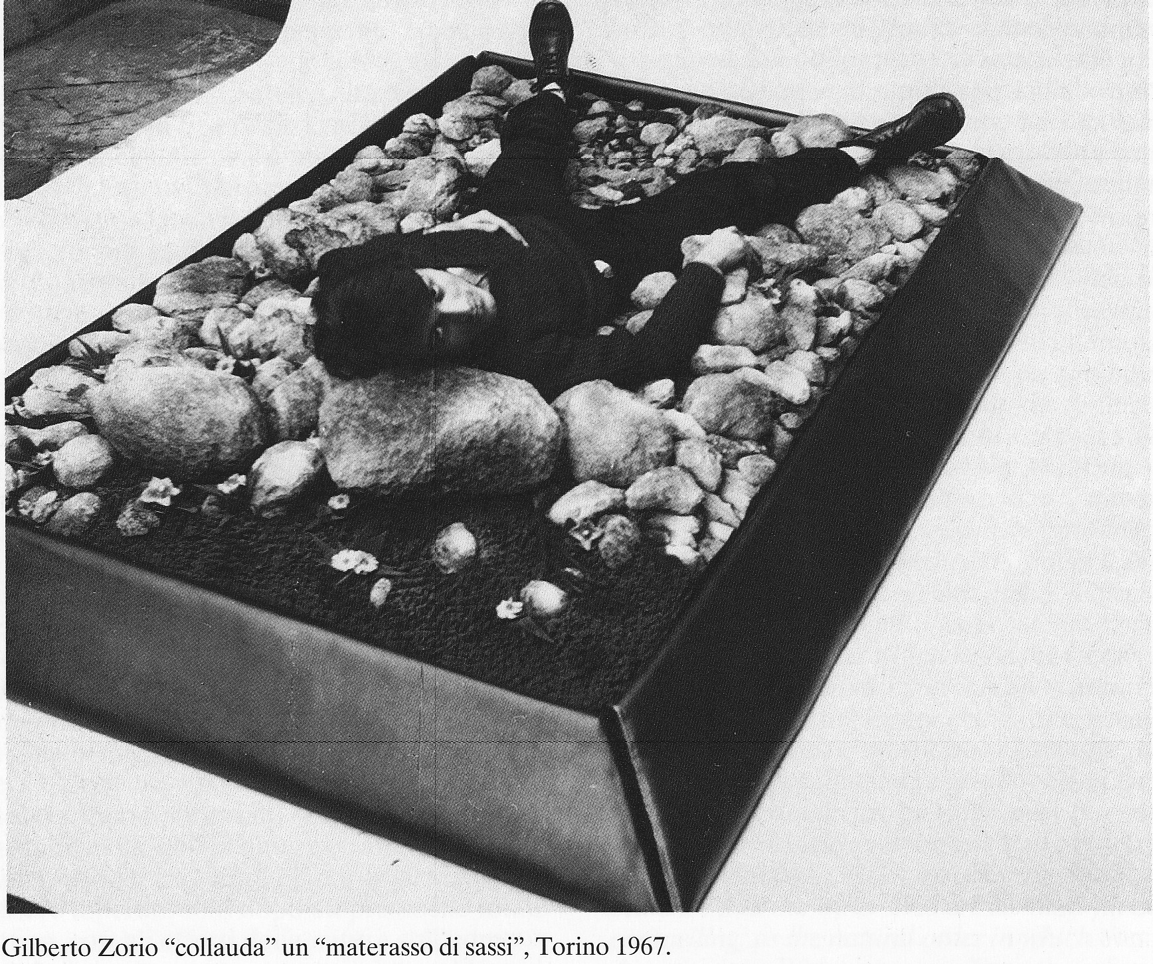
Gilberto Zorio 'tests' a 'mattress of stones' by Gilardi

The relationship between 'art' and commercial design was sometimes complex. Piero Gilardi, for example, variously assumed an identity as artisan and worker and played with the notion of making art as if it were just another commodity. At the same time, he saw his work for the design company, Gufram, as a strategic choice and a way of funding other activities, and therefore as distinct from his work as an artist.
It would be interesting to map the various positions and itineraries of this borderland: one could take the case or Armando Testa, the advertising man and graphic designer who dreamt of becoming a painter, or that of Michelangelo Pistoletto, who worked for a while in Testa's office before becoming a full-time artist. Ettore Sottsass was a designer and architect but made ceramics for an exhibition entitled "Monumento alle tribù scomparse", which featured "Menhir Ziggurat Stupas Hydrants e Gas Pumps", held at the Sperone gallery n 1967.
The border between art and design was a territory of exchange and traffic as well as dispute and contestation. This paper reconnoitres artists' relationship, in a broad sense, to the domestic world of designed objects by looking at the work of three Turin-based artists associated with Arte Povera, namely Piero Gilardi, Gilberto Zorio, and Mario Merz.

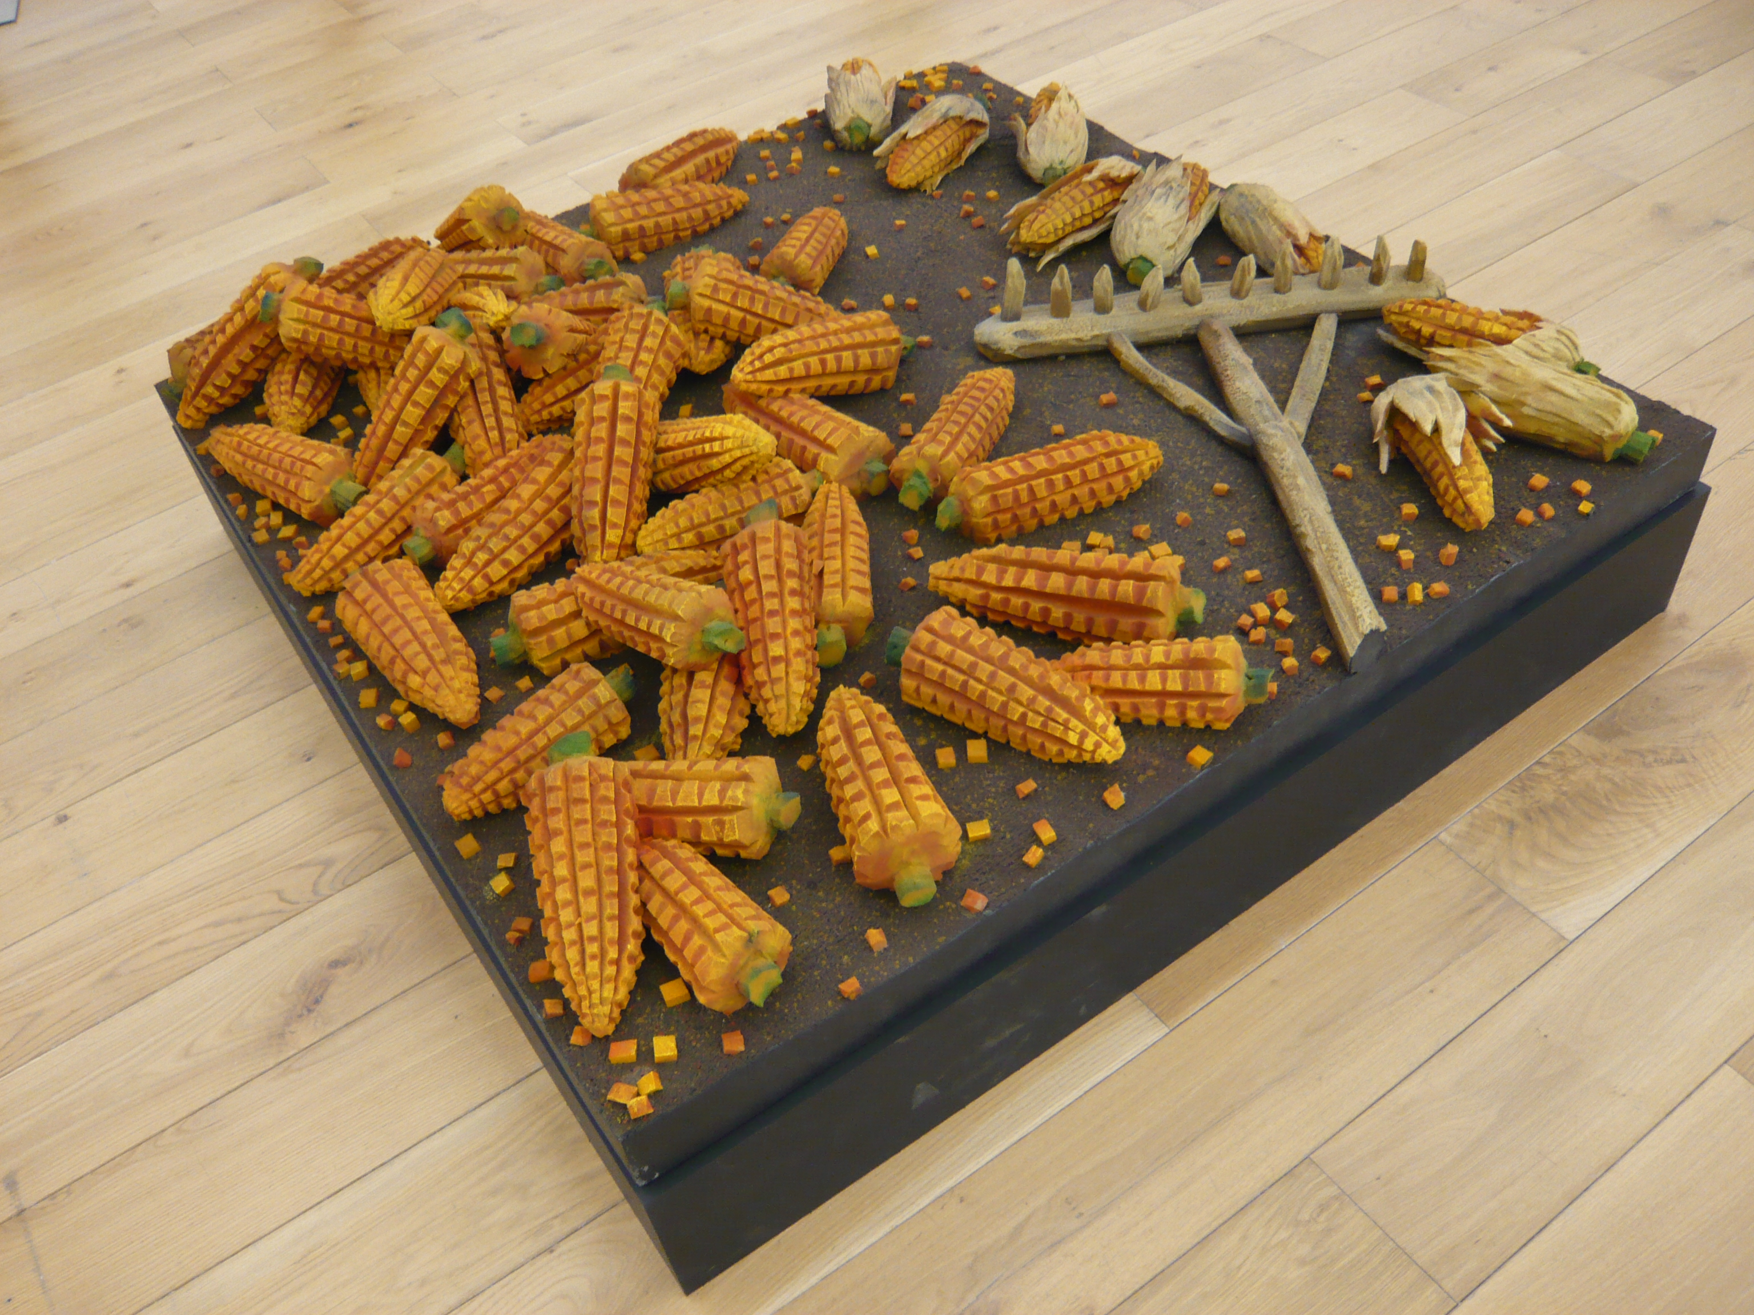
Piero Gilardi, Mais (Corn, 1967)

